**Peer Evaluation for Lab 6 – Case 1 and Case 2 from Tutorial 12 (HTML)**

|  |  |
| --- | --- |
| Your name: (Your lab is the one being evaluated) | Amanda Akins |
| Name(s) of peer evaluator(s) | Sylvia Rangel |
| Date: | 3/1/16 |

Instructions  
You should have already completed Lab 6. After you and a peer have evaluated your work, you will submit this evaluation along with screen shots indicated in moodle. You may make corrections to your work as a result of the evaluation. Submit only the updated version in moodle and to citstudent.

|  |  |
| --- | --- |
| ***Case 1*** | |
| Comment at the top of the file contains student name. | Yes |
| After the link element in the head section, a script element is inserted accessing an external js file AND function definitions are in the external file or in a script element at the top of the html file*?* | Yes |
| The solution contains function definitions for the following functions:   * showTable? * showSummary? | Yes |
| The definition of the function showTable   * Writes the “opening” elements for the table on the page as in 5a? * Contains a for loop that iterates from 0 to the number of the elements in the lastName array minus 1?   + In the loop body, writes a tr tag and a td element for the date, amount, first name, last name and address using the current element in each of the corresponding arrays, followed by a closing tr tag. * Writes the “closing” elements for the table as in 5d, e | Yes |
| The definition of the function showSummary   * Contains a for loop that iterates through the amount array, adding each element to the total in the body of the loop. * Writes the html for the table as shows in 7c. The number of elements in the lastname array is displayed for contributors and the total is displayed for total. | Yes |
| Script element is added to the figure for contributions that calls the function showSummary? | Yes |
| Script element is added to the figure for contributors data that calls the function showTable? | Yes |
| Page runs correctly in primary browser? Screen shot is included? | Yes |
| Page has been tested in another browser? Runs correctly and/or errors have been noted? Screen shot is included? | Yes |
| Files have been uploaded and tested on citstudent? | Yes |

|  |  |
| --- | --- |
| ***Case 2*** | |
| Comment at the top of the file contains student name. | Yes |
| After the link element in the head section, a script element is inserted accessing an external js file AND function definitions are in the external file or in a script element at the top of the html file*?* | Yes |
| The solution contains function definitions for the following functions:   * totalVotes? * calcPercent? * createBar? * showResults? | Yes |
| The definition of the function totalVotes   * Has a parameter called votes which is an array? * Contains a for loop that iterates through the votes array. The body of the loop contains one statement that adds the current element in the votes array to the total? | Yes |
| The definition of the function createBar   * Has 2 parameters, partyType which is a string and percent which is an integer? * Contains a switch statement that sets the variable barText with a td element with a style that depends on the party type? * Contains a for loop that writes barText from 1 to the percent of votes earned by that candidate | Yes |
| Script element is added below the h1 tag for congressional races that calls the function showResults 5 times changing the parameters in each call? The first parameter, race is an element in the race array. The other parameters are array names. | Yes |
| Page runs correctly in primary browser? Screen shot is included? | Yes |
| Page has been tested in another browser? Runs correctly and/or errors have been noted? Screen shot is included? | Yes |
| Files have been uploaded and tested on citstudent? | Yes |

|  |  |
| --- | --- |
| ***Programming style for all programs*** | |
| Is proper indentation used? | Yes |
| Are comments used appropriately? | No |
| Are variables declared with the keyword var? Do variable names use camel case? (camelCase for example) | Yes |

General comments and notes: Case 2 doesn’t take up the whole page… it bugs me.

Screen Shots Case 1:

Chrome -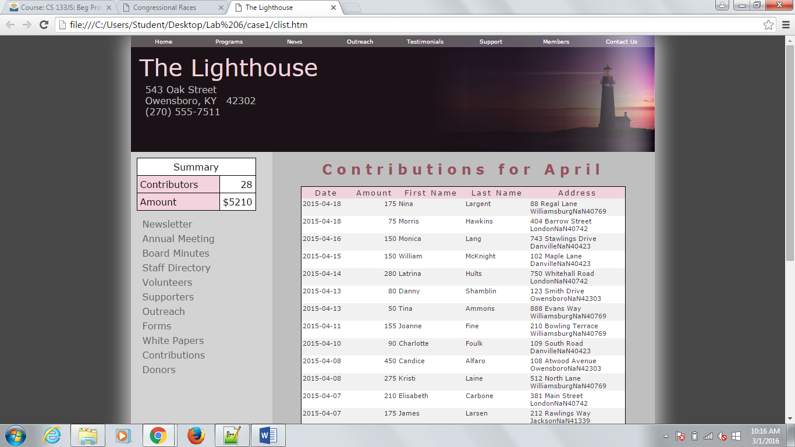

Firefox –

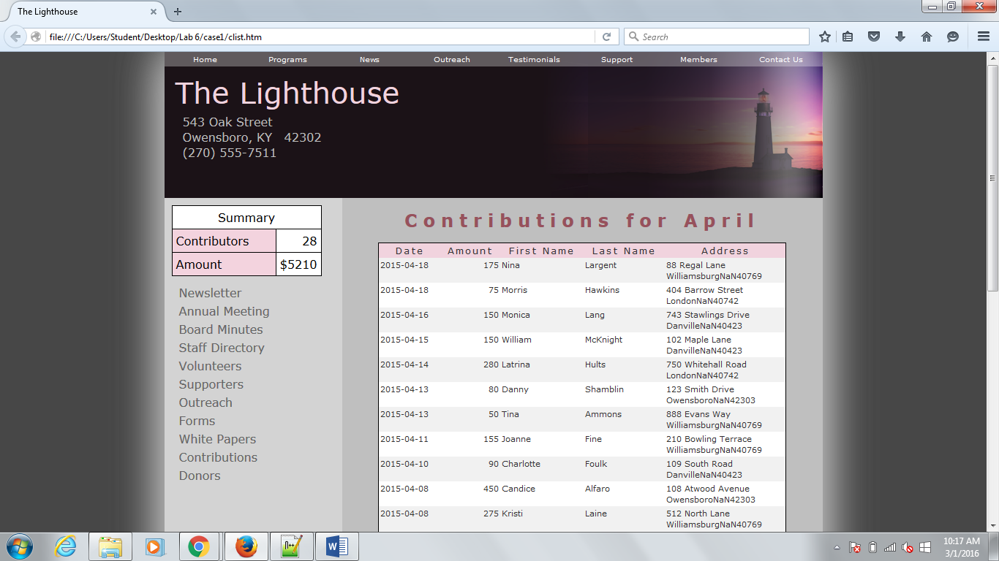

Screen Shots Case 2:

Chrome –

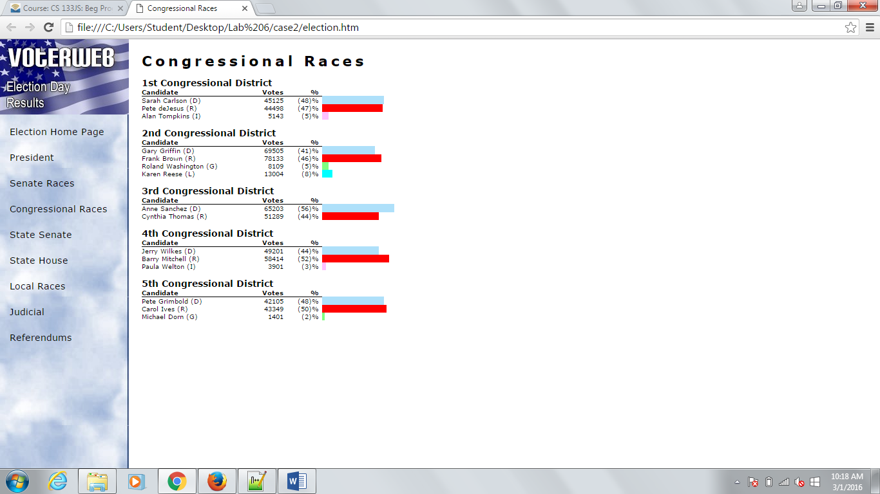

Firefox –

